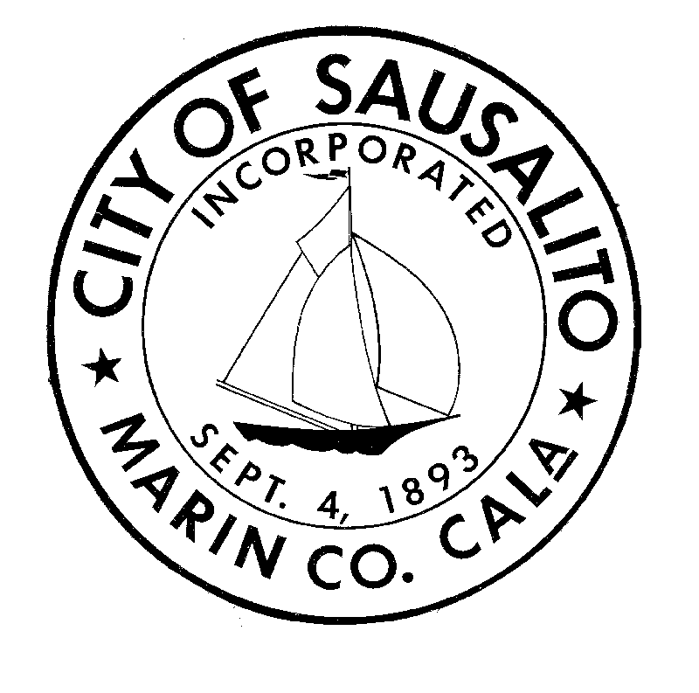
SAUSALITO CITY COUNCIL AGENDA
SPECIAL MEETING

SATURDAY, MAY 10, 2008
4:00 P.M. in the COUNCIL CHAMBERS at 420 LITHO STREET, SAUSALITO, CA

Note that the City Council may, at its discretion, consider agenda items out of the order in which they are listed. The public may comment on any item on the agenda that has not previously been subject to public comment. To give everyone an opportunity to be heard and to ensure the presentation of different points of view, Council requests that members of the audience who speak: 1) Always address the Chair; 2) State his/her name; 3) State views succinctly; and 4) Limit presentations to three (3) minutes.

For information on how to obtain the City Council meeting agenda and agenda packets,
please see the last page of this agenda.

For information concerning reasonable accommodations under the
Americans with Disabilities Act, please see the last page of this agenda.

CALL TO ORDER IN THE COUNCIL CHAMBERS AT CITY HALL, 420 LITHO STREET

A. Roll Call

B. Pledge of Allegiance

C. Approval of Agenda

COMMUNICATIONS (Not to exceed 15 minutes)

PUBLIC COMMUNICATIONS: This is the time for the City Council to hear from citizens regarding matters that are not on the agenda. Comments on matters that are on the agenda shall be made at the time the Council considers those matters. Except in very limited situations, state law precludes the Council from taking action on or engaging in discussions concerning items of business that are not on the agenda. However, the Council may refer matters not on the agenda to City staff or direct that the subject be agendized for a future meeting. Speakers are limited to 3 minutes each.

BUSINESS ITEMS

- Appoint Councilmember City Clerk Pro Tem for duration of meeting

1. Oral report and City Council questions
2. PUBLIC COMMENT – limited to 3 minutes/person
3. City Council discussion and direction

B. Take Action on the Retaining Wall Reimbursement Agreement (City Attorney Mary Wagner)

1. Oral report and City Council questions
2. PUBLIC COMMENT – limited to 3 minutes/person
3. City Council discussion and direction
ADJOURNMENT
The next regular meeting of the City Council is scheduled for May 20, 2008.

How to obtain City Council Agendas
Posted agendas:
Agendas are posted the Friday prior to the City Council meeting date, at the entrance to City Hall at 420 Litho Street
View on the Internet:
Follow the link to Council agenda, at: http://www.ci.sausalito.ca.us/business/council/index.htm
Send a request to Debbie Pagliaro at Dpagliaro@ci.sausalito.ca.us
City Clerk’s Office:
Go to City Hall, 420 Litho Street, Sausalito, and ask for a copy at the Administration counter.
Council Meetings:
Agendas are available at the City Council meeting.

How to obtain City Council Agenda Packet Materials
City Clerk’s Office or the Library:
A copy of the complete agenda packet is available for public review on the Friday prior to the City Council meeting, at the Administration counter and the Library, at 420 Litho Street, Sausalito.
View Staff Reports on the Internet:
Current Agendas and Staff Reports are available at the City website at www.ci.sausalito.ca.us
Council Meetings:
A complete agenda packet is available for review at the City Council meeting.

How to Stay “In the Loop”!
To subscribe to the City’s e-mail distribution service for announcements about upcoming City events including Council meetings, forums, and a variety of special events, please request to have your name added to the distribution list. Either e-mail your request to InTheLoop@ci.sausalito.ca.us, or phone Ms. Dale Vaughn at 289-4130.

Special Needs
In compliance with the Americans with Disabilities Act (28 C.F.R. 35.102-35.104, ADA Title II), if you need special assistance to participate in this City Council meeting, please contact Debbie Pagliaro at (415) 289-4165. Notification 48 hours prior to the meeting will enable the City to make reasonable arrangements to ensure accessibility to this meeting.

City of Sausalito
420 Litho Street
Sausalito, CA 94965
(415) 289-4100
www.ci.sausalito.ca.us

Amy Belser, Mayor |  | Adam Politzer, City Manager
Paul Albritton, Vice Mayor |  | Mary Wagner, City Attorney
Mike Kelly, Councilmember |  | Louise Ho, Finance Director
Jonathan Leone, Councilmember |  | Jeremy Graves, Community Development Director
Herb Weiner, Councilmember |  | Todd Teachout, City Engineer
 |  | Scott Paulin, Chief of Police
 |  | Denis Walsh, Fire Chief
 |  | Mary Richardson, City Librarian
 |  | Michael Langford, Parks & Recreation Director
 |  | VACANT, Public Works Director

