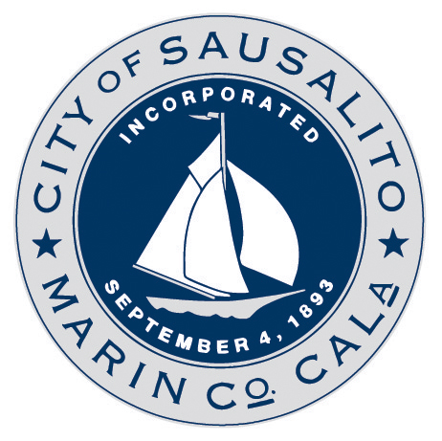
NOTICE OF PUBLIC HEARING
HEARING DATE | WEDNESDAY, FEBRUARY 17, 2021 at 6:30 PM
HEARING LOCATION | Pursuant to Section 3 of Governor Newsom’s Executive Order N-29-20 the meeting will be conducted telephonically through Zoom and broadcast live at www.sausalito.gov. City Hall will not open for the meeting, Commission members and the public will be participating telephonically and will not be physically present in the Council Chambers. The agenda will contain details regarding how to virtually participate in the meeting and provide public comment prior to and during the meeting (www.sausalito.gov/city-government/boards-and-commissions/planning-commission/meetings-and-agendas).
HEARING BODY | Planning Commission
PROJECT ADDRESS/ID  /APN | 719-725 BRIDGEWAY  PROJECT ID: DR-CUP-EA-TM-TRP-SP 17-487  APN: 065-071-21
PROJECT CONTACT | Contract Planner Sheldon Ah Sing  Email: SAhsing@m-group.us
PROJECT  SUMMARY | Applicant Michael Rex, on behalf of the property owner Langsam Properties I, LLC is requesting adoption of an Initial Study/Mitigated Negative Declaration and approval of a Design Review Permit with Heightened Design Review, Conditional Use Permits for formula retail and parking exceptions, a Minor Use Permit for sidewalk dining, Sign Permits, an Encroachment Permit for a projecting sign and bay windows and fencing associated with sidewalk dining, a Tentative Parcel Map to create three residential condominiums and a retail condominium parcel, and a Tree Removal Permit to demolish the existing on-site building and construct a new two-story mixed use building of similar size at 719-725 Bridgeway. An Initial Study/Mitigated Negative Declaration (IS/MND) has been prepared for the project pursuant to the California Environmental Quality Act (CEQA). The IS/MND was previously circulated for public review from February 18, 2020 to March 18, 2020. The Planning Commission will consider adoption of the IS/MND at the public hearing in addition to approval of the project. At the meeting the Planning Commission will consider all public testimony and decide whether to approve, deny, or modify the project. The Planning Commission may also decide to continue the public hearing or request additional information.
FOR MORE INFORMATION: | Project materials are available for public review online only: https://saus-trk.aspgov.com/eTRAKiT  You can search using the project address, project ID number, or APN listed above.
HOW TO COMMENT: | All persons are welcome to comment on the project. You can comment on the project via email to the project contact. The deadline to submit written comments is on the day of the hearing, by 4:30 PM on February 17, 2021. You may also comment orally during the hearing.

